**GOVERNMENT ARTS AND SCIENCE COLLEGE FOR WOMEN**

**SATHANKULAM-628704**



**PREDICTING PERSONAL LOAN APPROVAL USING**

**MACHINE LEARNING**



**A PROJECT REPORT SUBMITTED BY**

**LEADER: C. AIYSHA**

**TEAM MEMBERS:**

**1. M.MUTHULAKSHMI**

**2. A.THANGA ESWARI**

**3. B.SUBA**

1. **INTRODUCTION:**

A personal loan is a loan that does not require collateral or security and is offered with minimal documentation. You can use the funds from this loan for any legitimate financial need. Like any other loan, you must repay it accordance to the agreed terms with the bank.

A personal loan is an amount of money you can borrow to use for a variety of purposes. For instance, you may use a personal loan to consolidate pay for home renovations, or plan a dream wedding. Personal loans can be offered by balanced.

A loan is a redistribution of financial assets over a time between the lender and the giver of the loan. The borrower initially receives an amount of money from the lender, which they pay back usually but not always in regular installments to the lender. This service is generally provided at a cost, discounted as interest on the dept, to the lender. Acting as a principal of loans is one of the principal task for financial institution for banks. Loans are generally funded by deposits for other institution issuing of debt contract, such as bonds is a typical form of funding.

Personal loan are better choice compared with consumer durable loans. In fact before we consider taking a consumer durable loam we might consider a personal loan instead as the procedure is slightly longer but the rate of interest is lower. Flexibility of duration and availability of various schemes make personal loan an attractive option.

**1.1 OVERVIEW:**

A loan is a sum of money that is borrowed and repaid over a period of time, typically with interest. There are various types of loans available to individuals and businesses, such as personal loans, mortgages, auto loans, student loans, business loans and many more. They are offered by banks, credit unions, and other financial institutions, and the terms of the loan, such as interest rate, repayment period, and fees, vary depending on the lender and the type of loan.

A personal loan is a type of unsecured loan that can be used for a variety of expenses such as home repairs, medical expenses, debt consolidation, and more. The loan amount, interest rate, and repayment period vary depending on the lender and the borrower’s credit worthiness. To qualify for a personal loan, borrowers typically need to provide proof of income and have a good credit score.

Predicting personal loan approval using machine learning analyses a borrower’s financial data and credit history to determine the likelihood of loan approval. This can help financial institutions to make more informed decisions about which loan application to approve and which to deny.

**1.2 PURPOSES**:

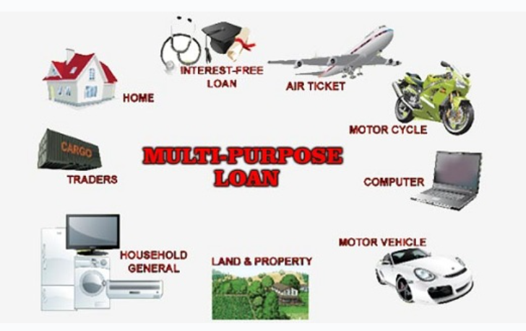

* Car loan
* Home improvement
* Marriage loan
* Home Renovation loan
* Small Business loan
* Debt Consolidation loan
* Personal loans are unsecured loans that can be used for a wide range of purposes.
* You can use personal loans for financing big-ticket expenses, funding a wedding, planning a vacation, covering medical expenses during emergencies, home renovation, and debt consolidation.
* Personal loan come with end-use restrictions, which means you can use the funds availed as per your requirement.
* A purpose loan can be used as per your requirement.
* Unlike secured loans such as home loans and auto loans, personal loans are unsecured and can be used for fulfilling a wide range of purposes.
* There are no end-use restrictions on the funds.
* The lender are financial institutions will not investigate your purpose once the funds are disbursed.
* A personal loan can be used for various reasons. These reasons can include
* Education
* Wedding

**PROBLEM DEFINITION AND DESIGN THINKING**

**2.1 EMPATHY MAP**

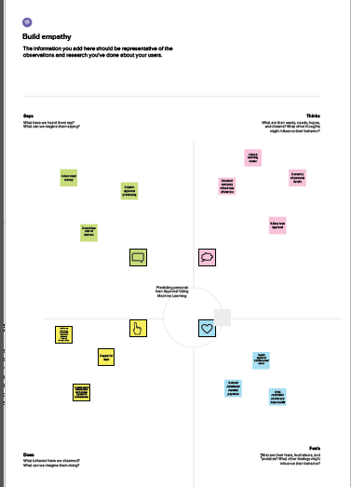

**2.2 IDEATION AND BRAINSTORMING MAP:**

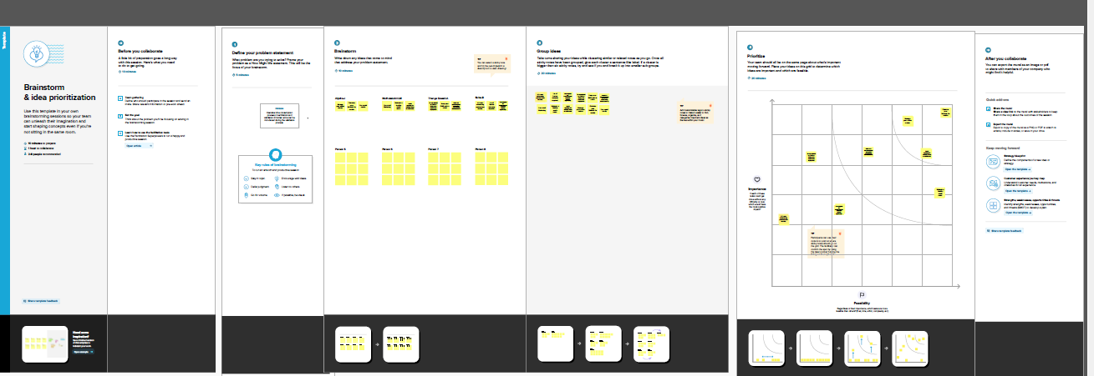

1. **RESULT:**

**Importing required libraries :**

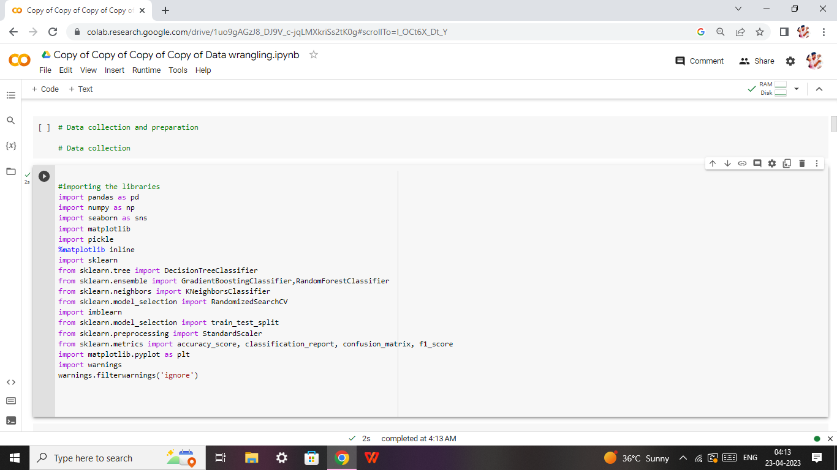**Read the excel file:**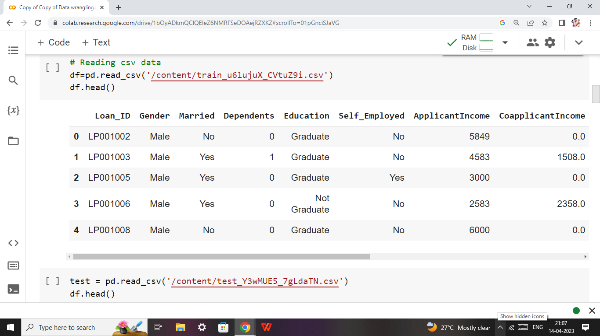

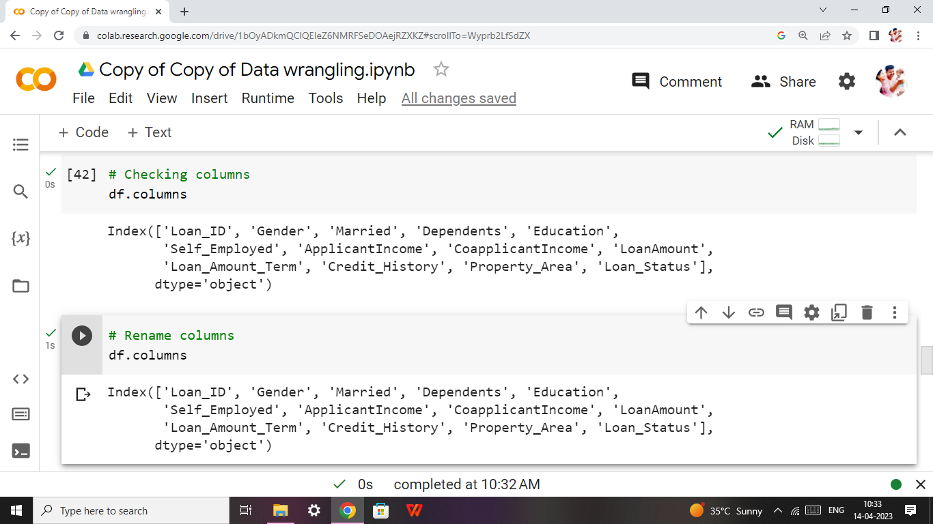

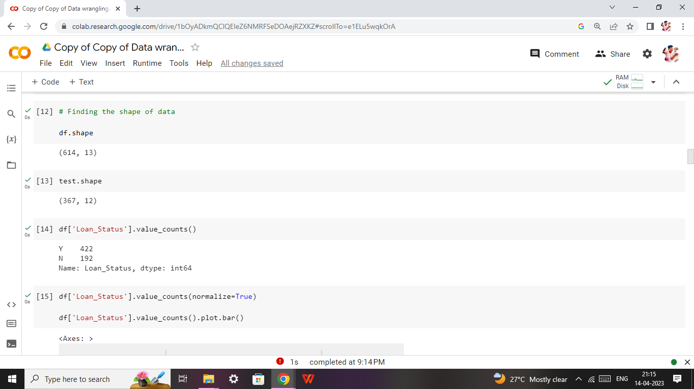

* **Split training and testing:**

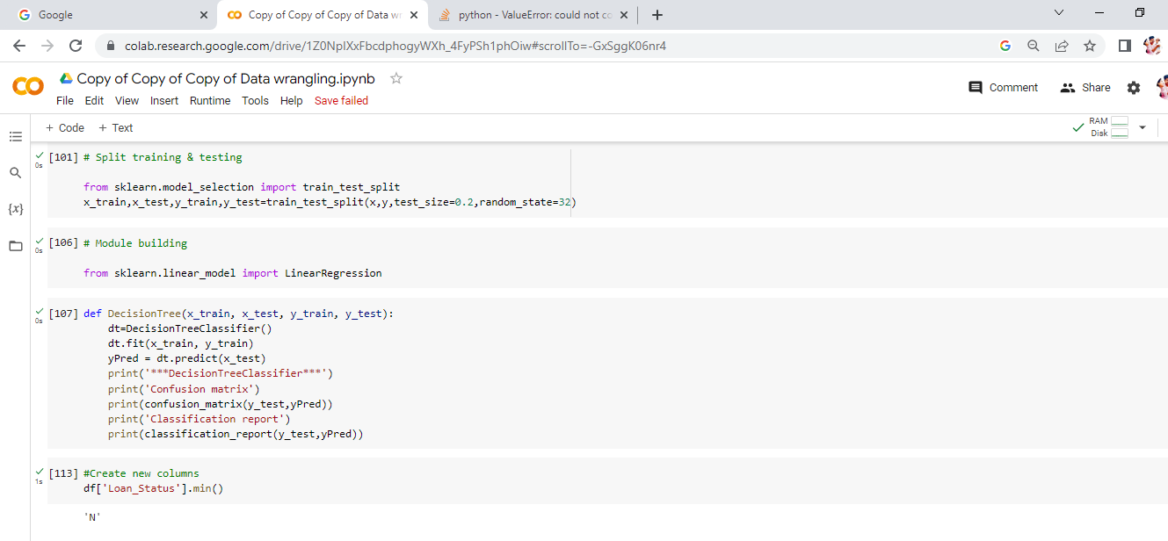

**Data.info():**

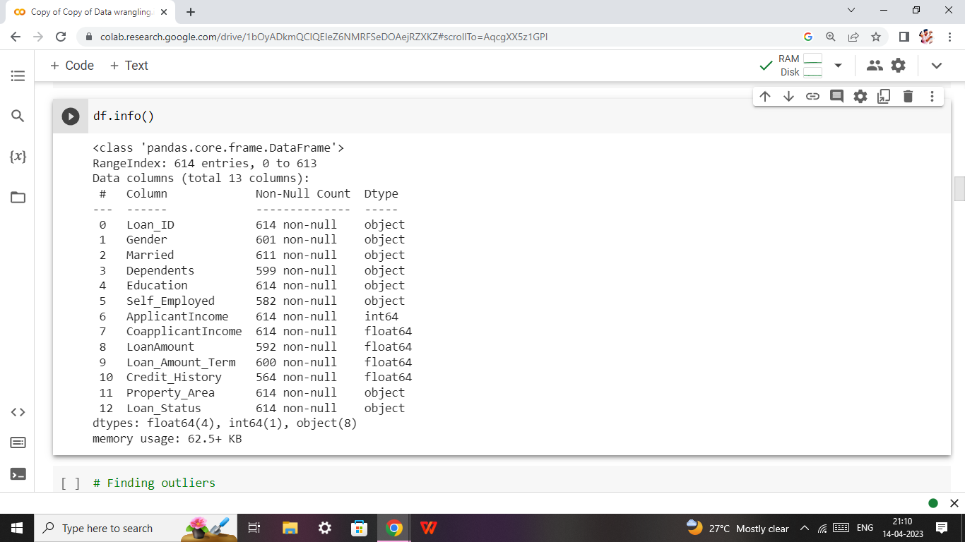

**Data.isnull().sum():**

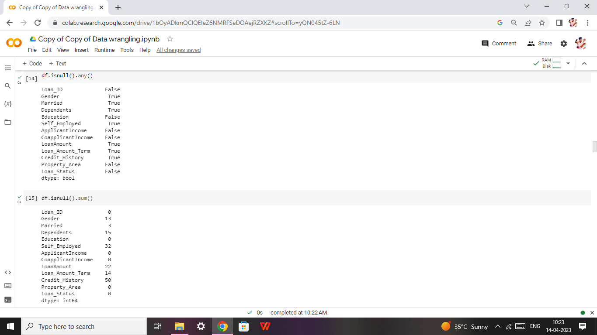

**Handling categorical columns:**

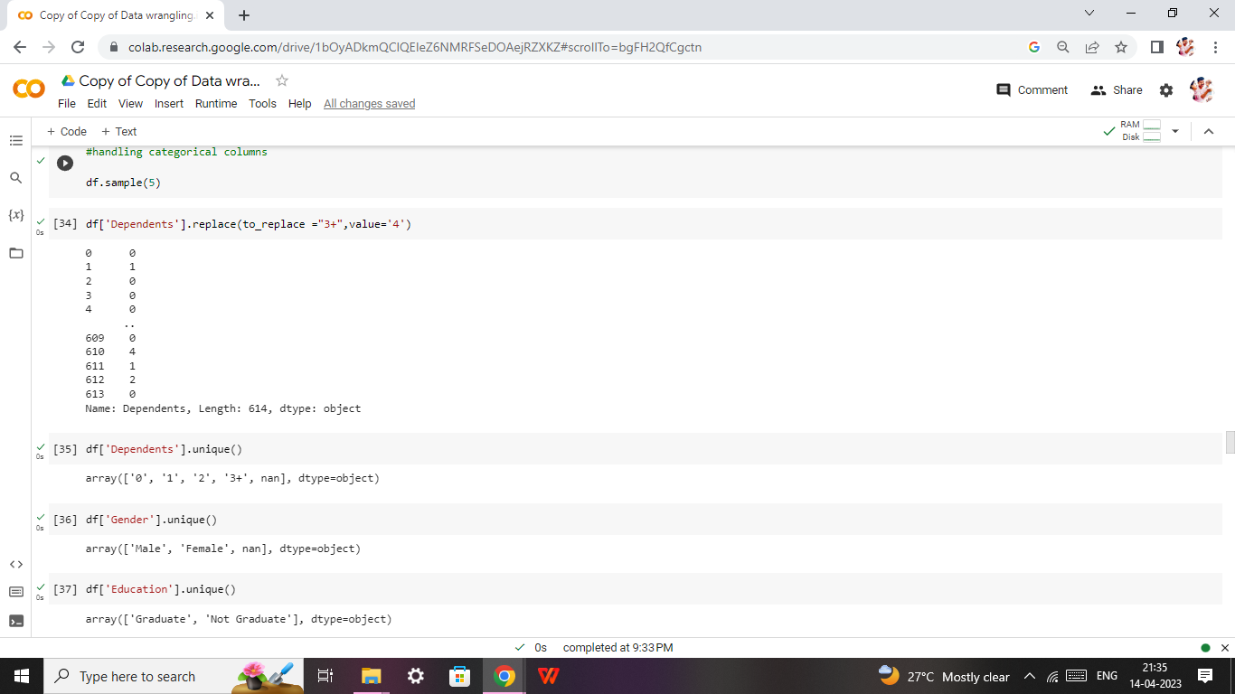

**Data Analysis:**

* **Descriptive Analysis:**
* **Descriptive statistical:**

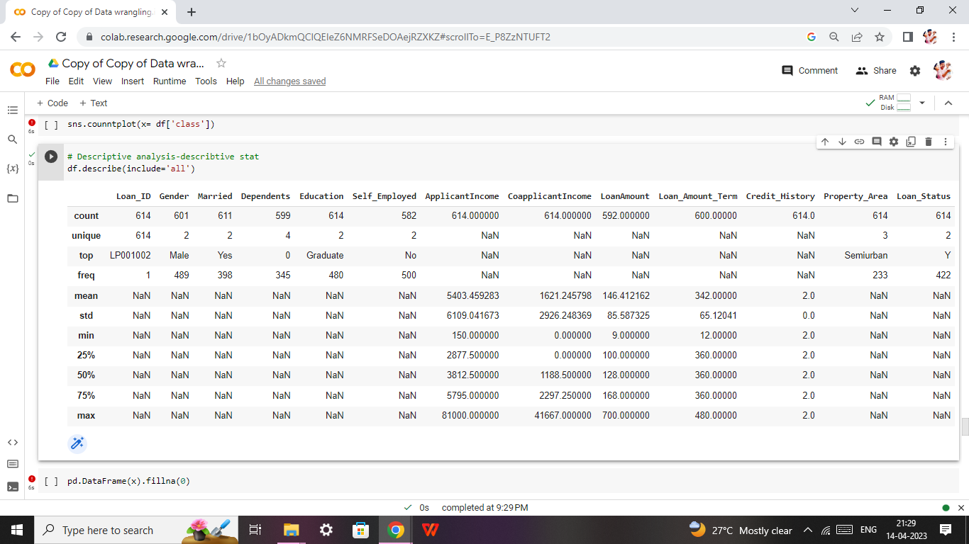

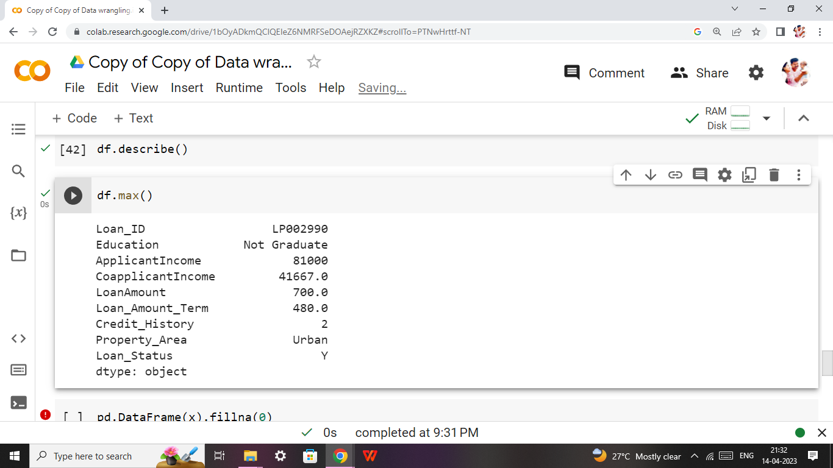

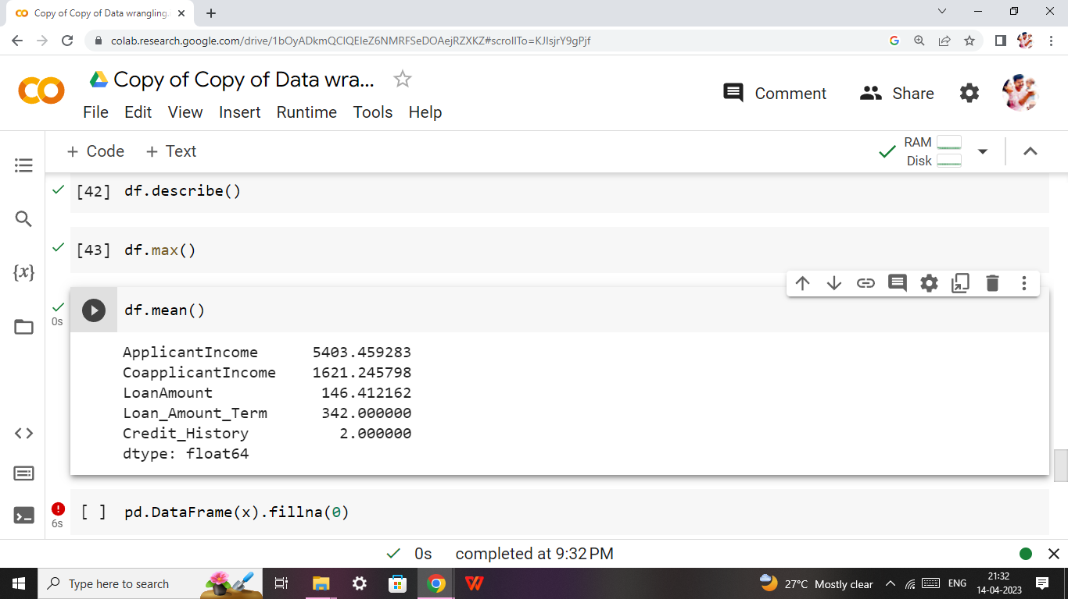

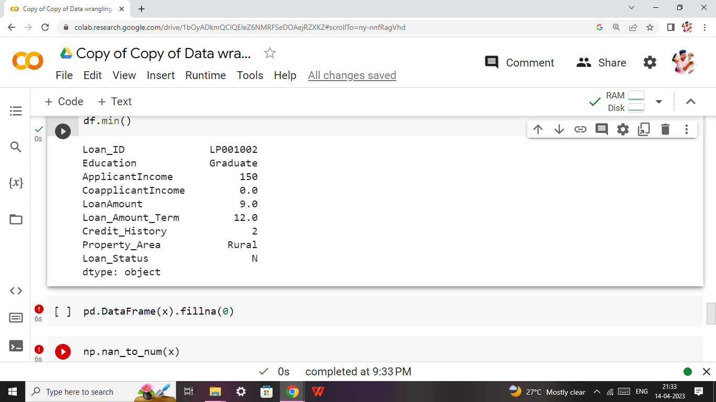

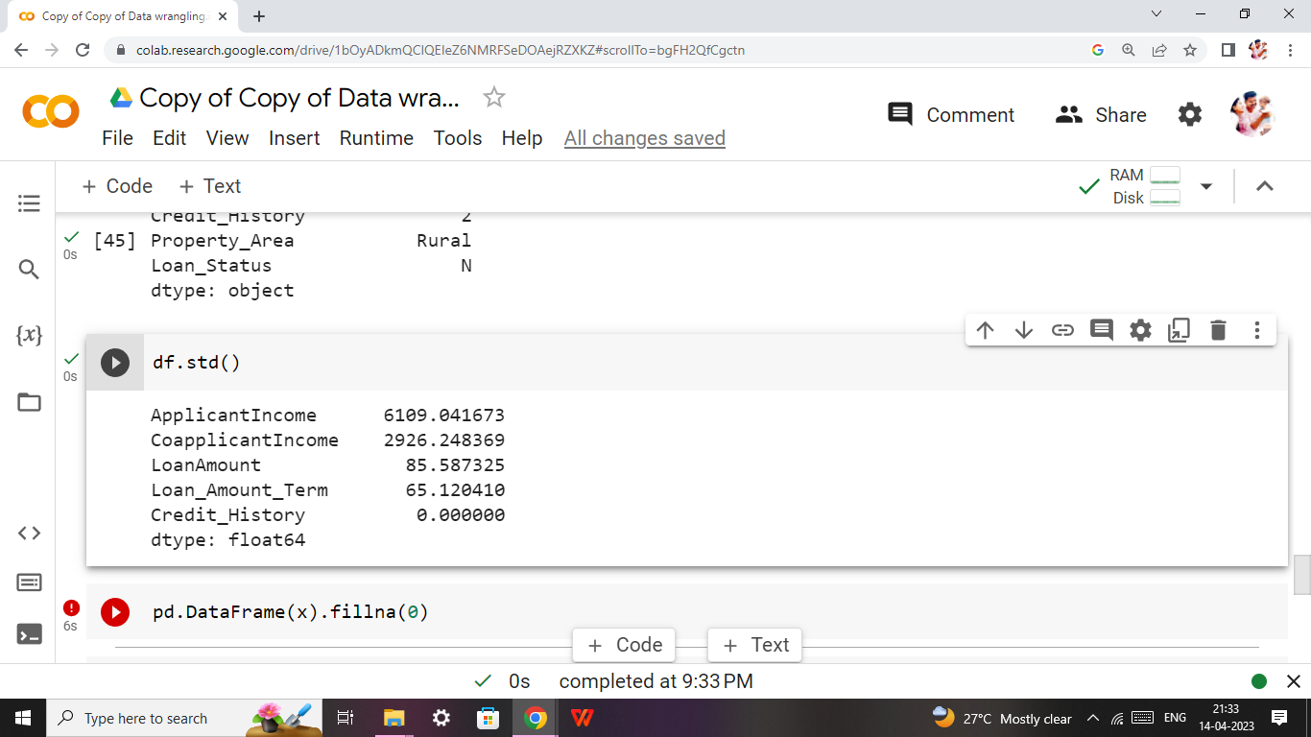

* **Visual Analysis**
* **Univariate Analysis**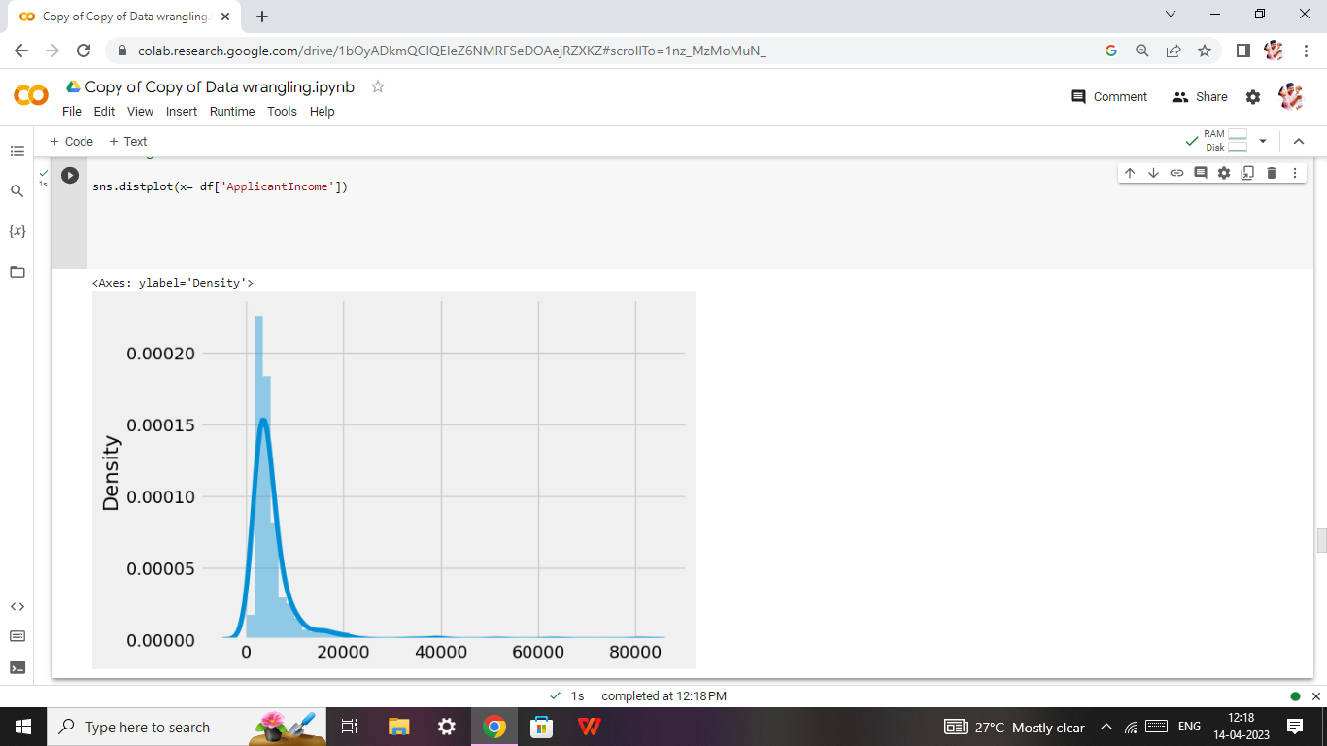

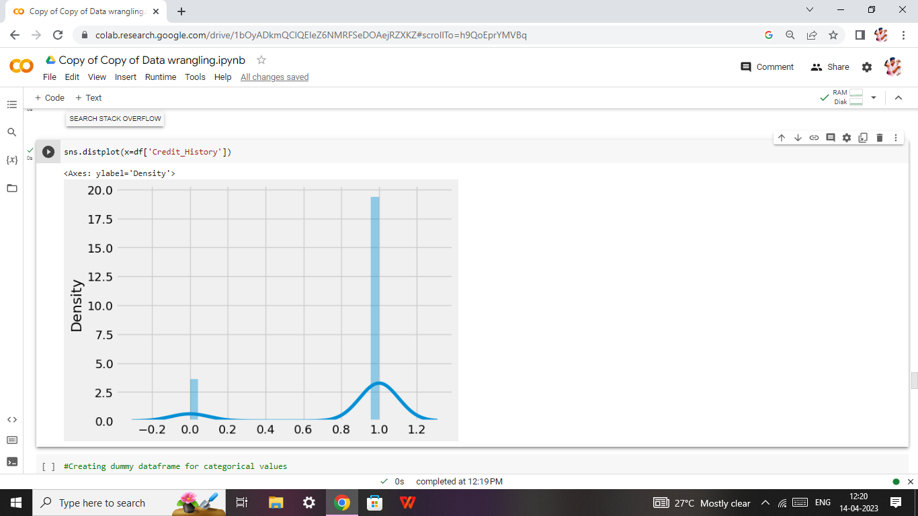

* **Bivariate Analysis:**

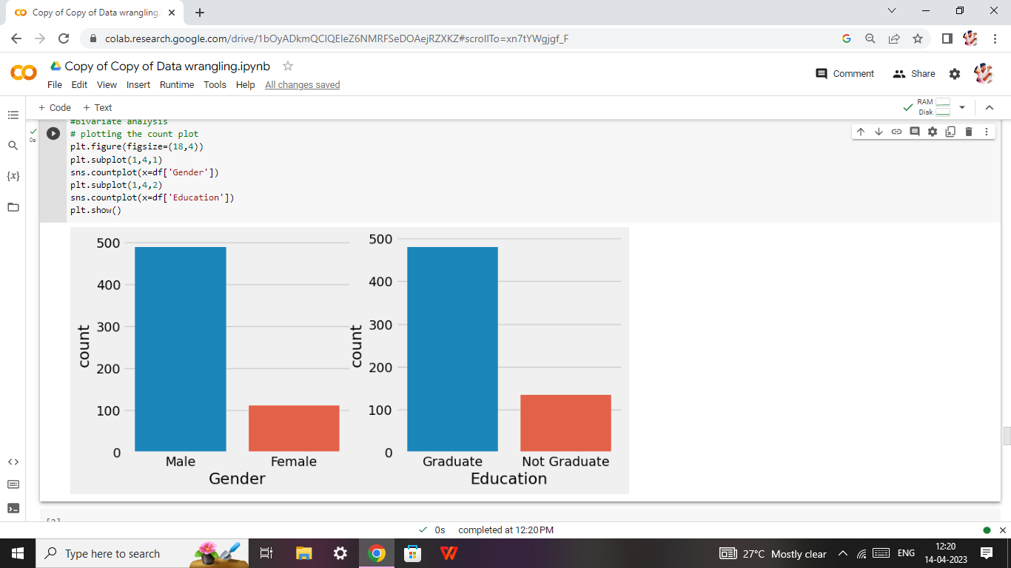

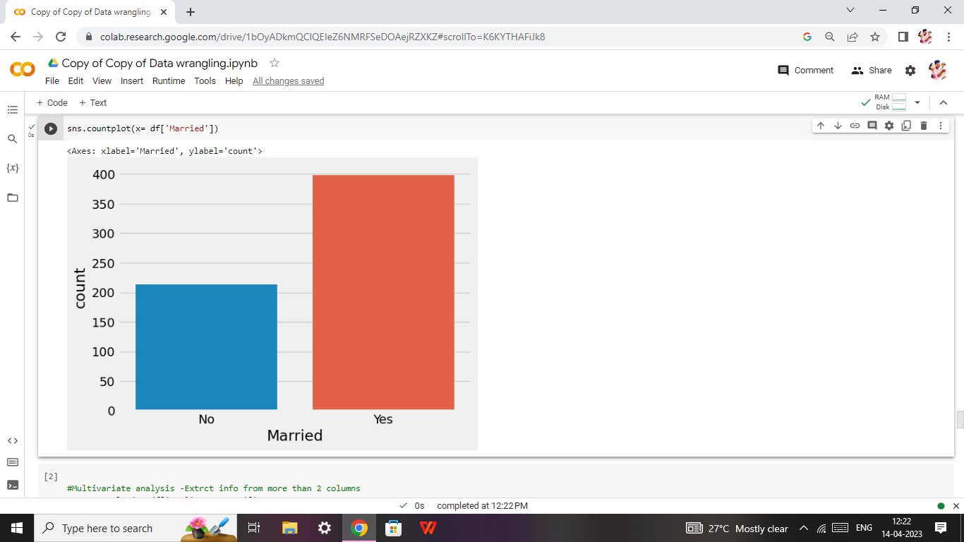

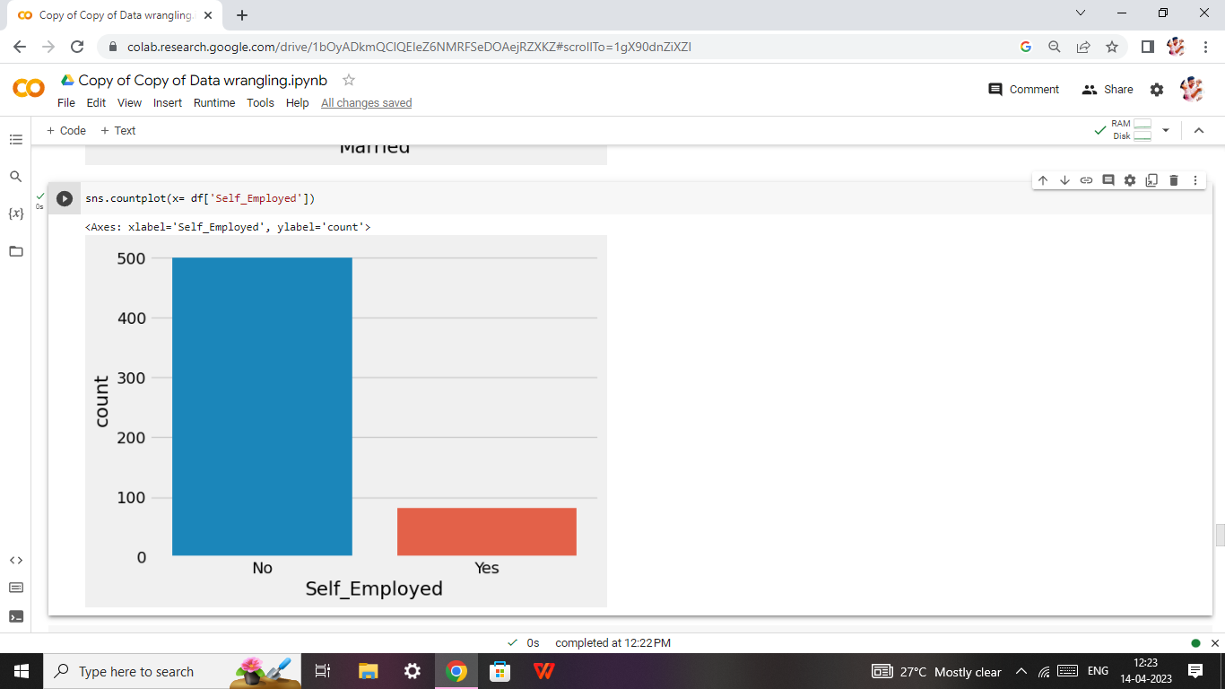

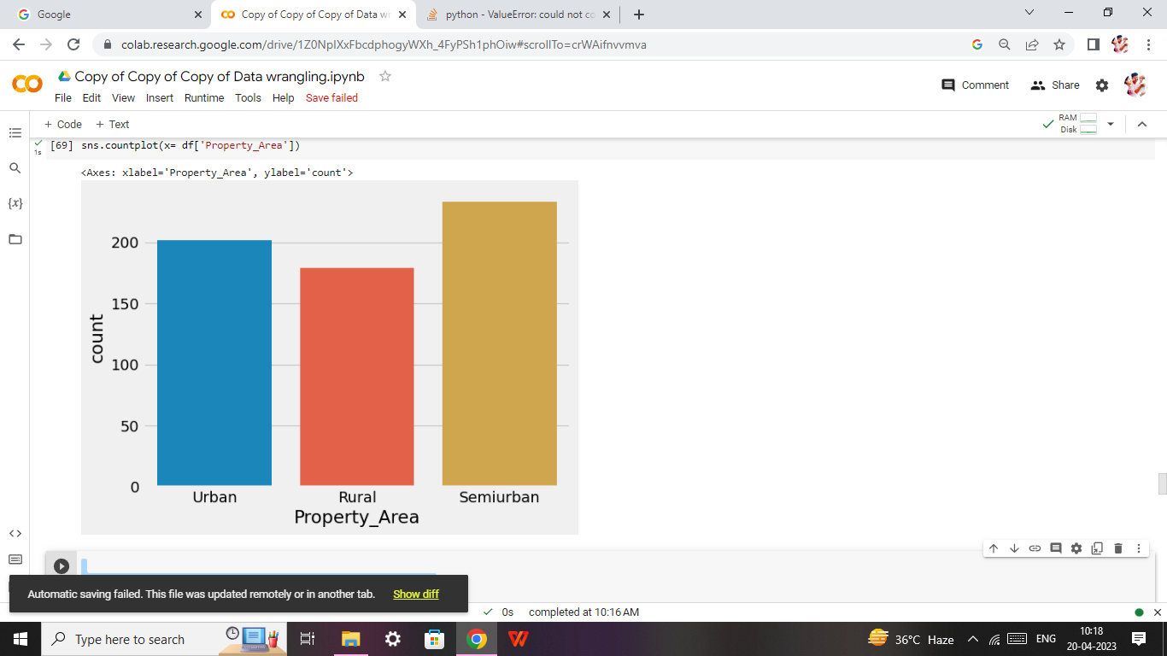

* **Multivariate Analysis:**

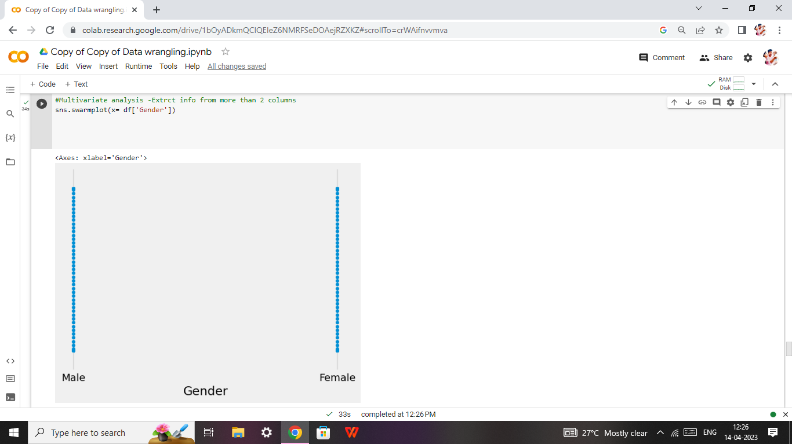

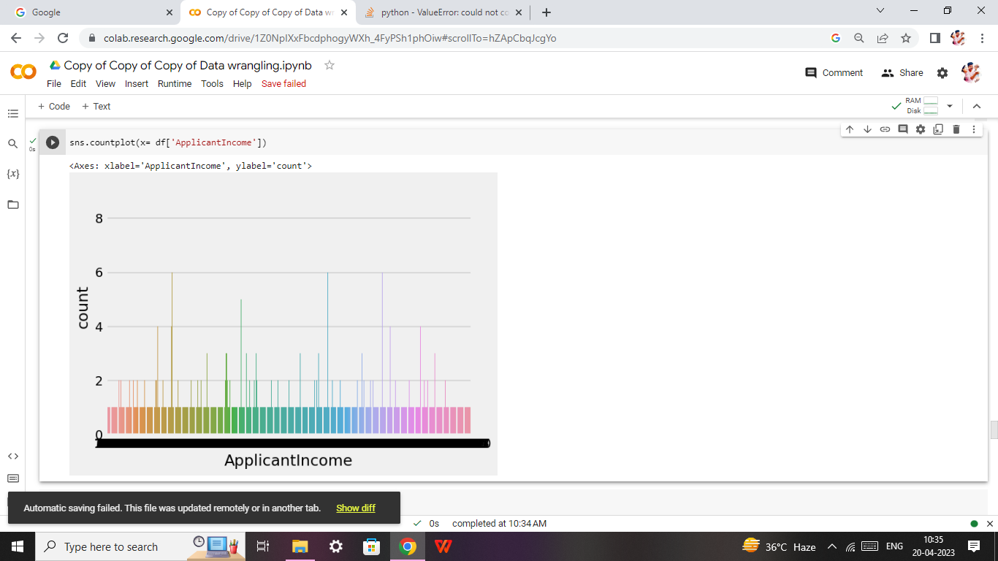

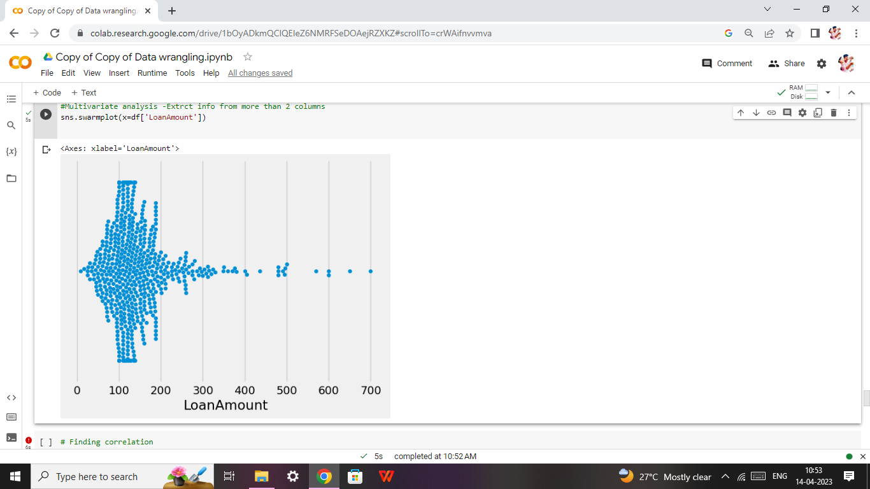

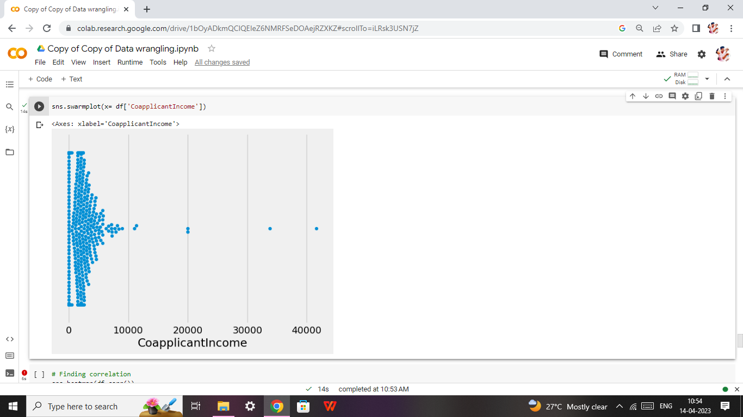

* **Findling Outliers:**

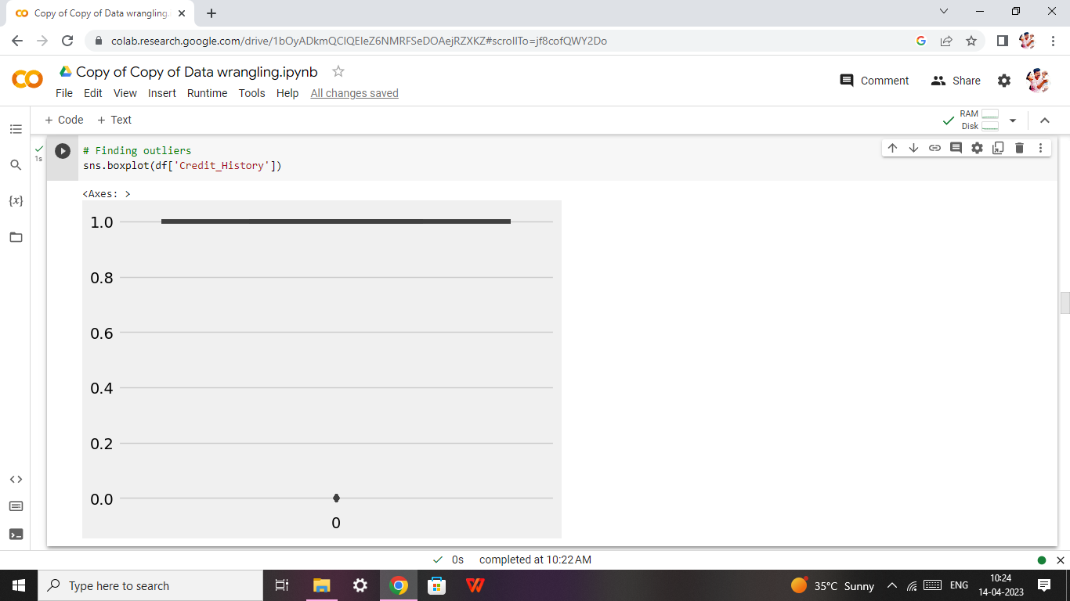

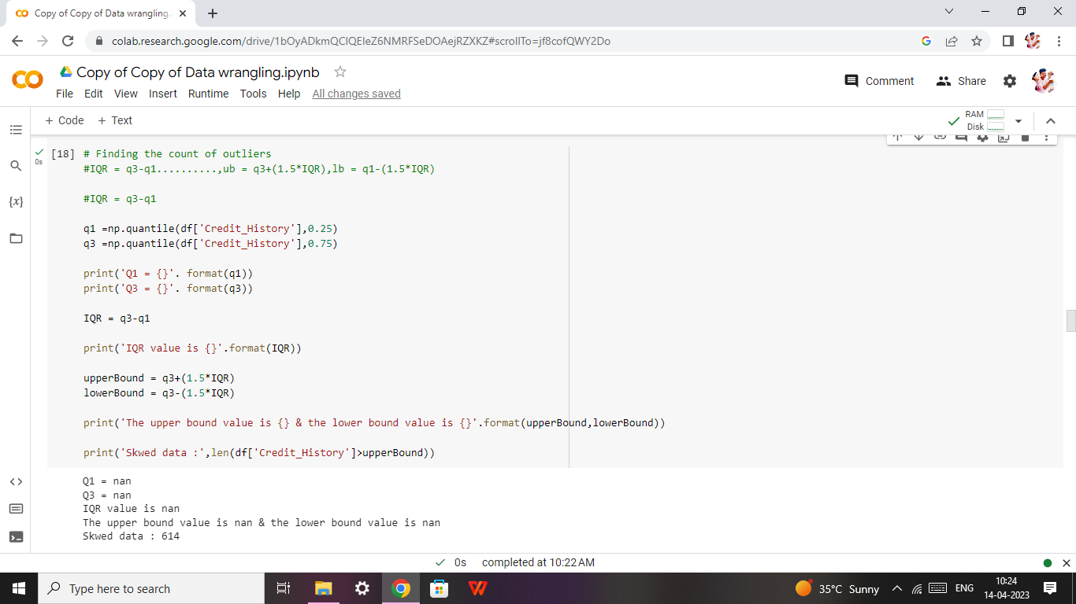

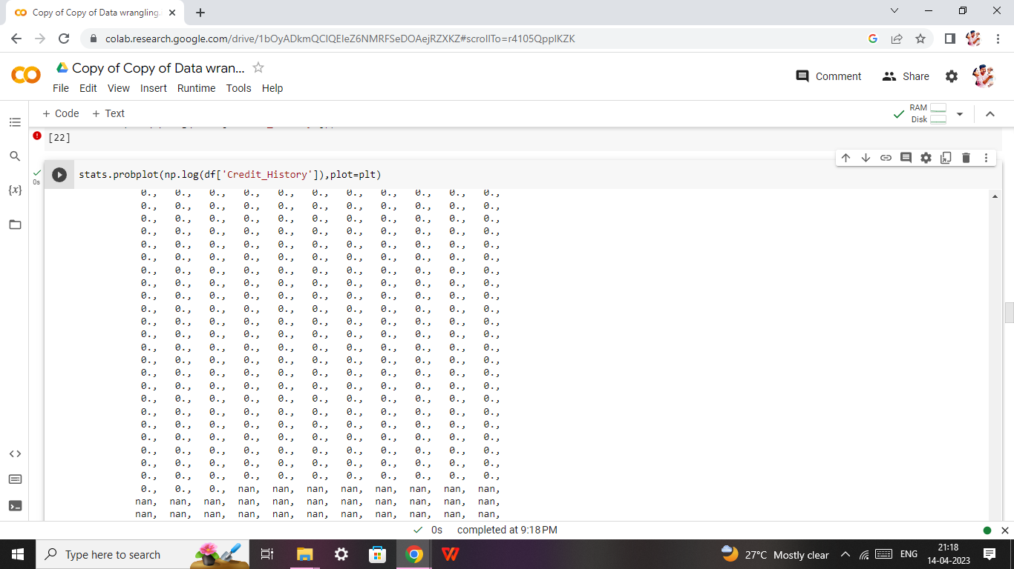

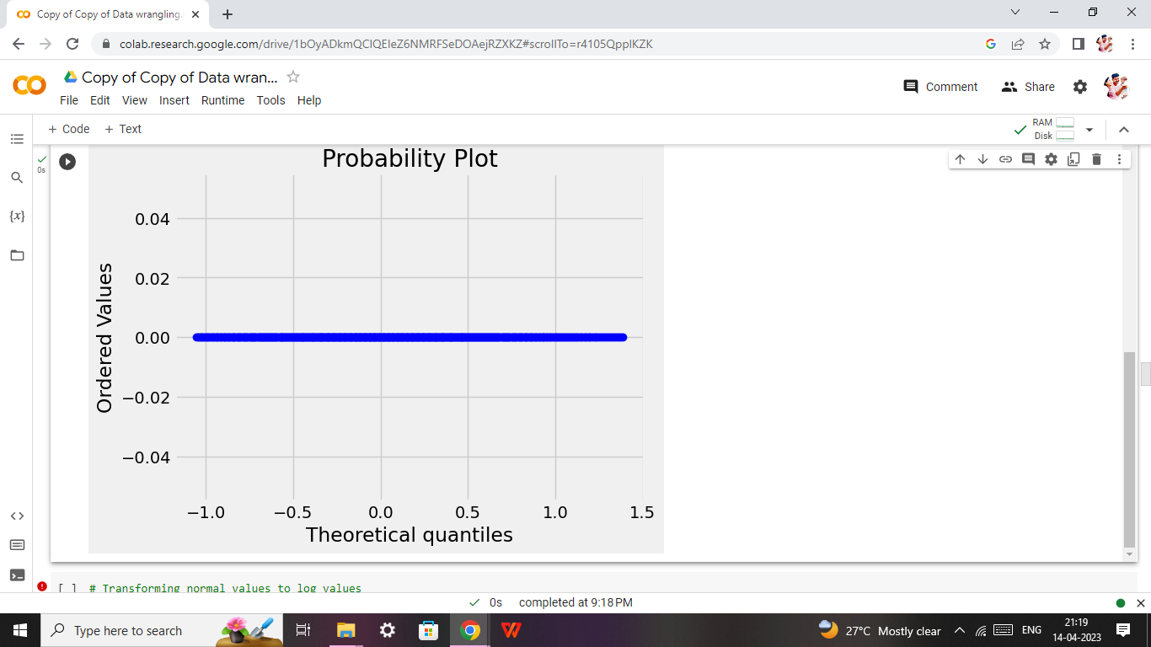

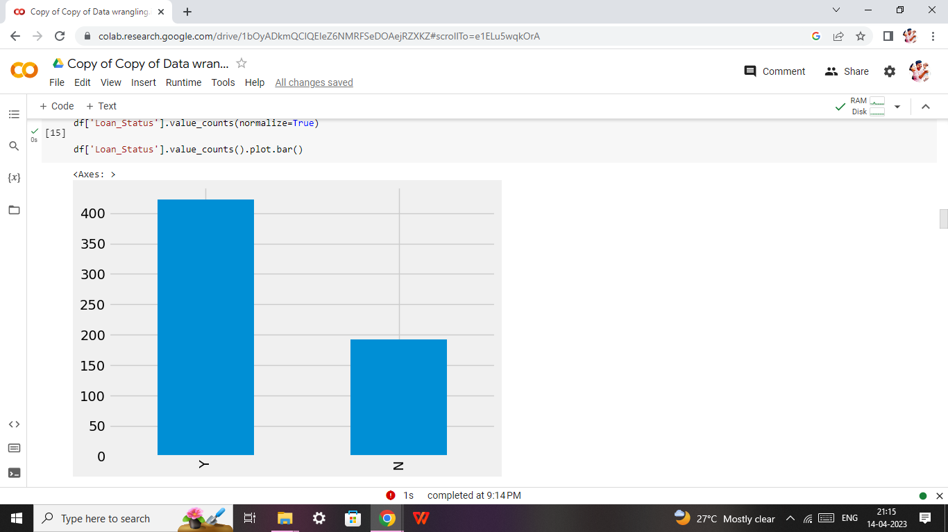

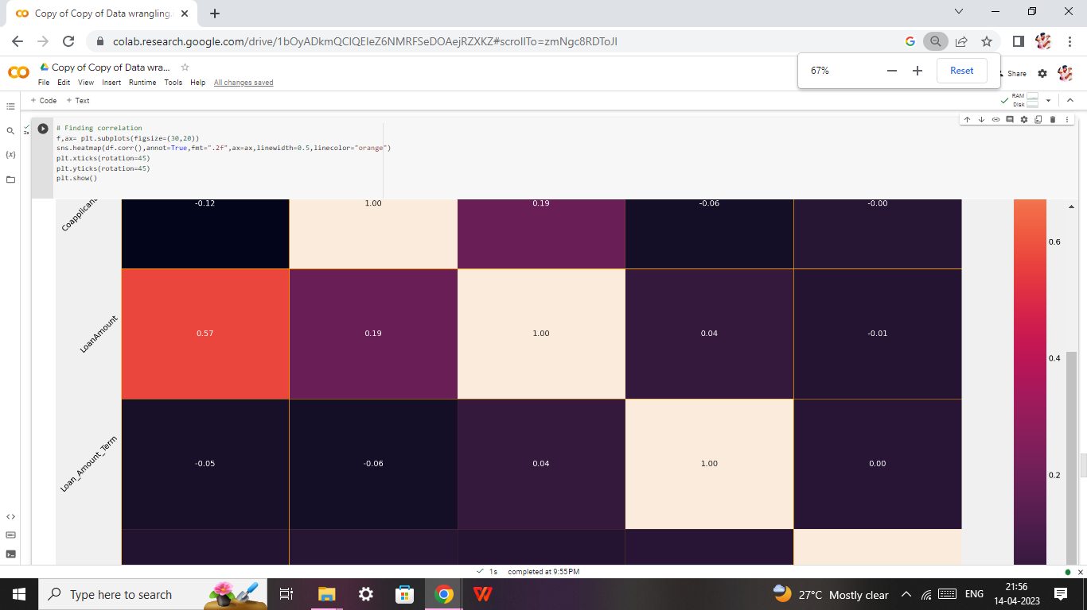

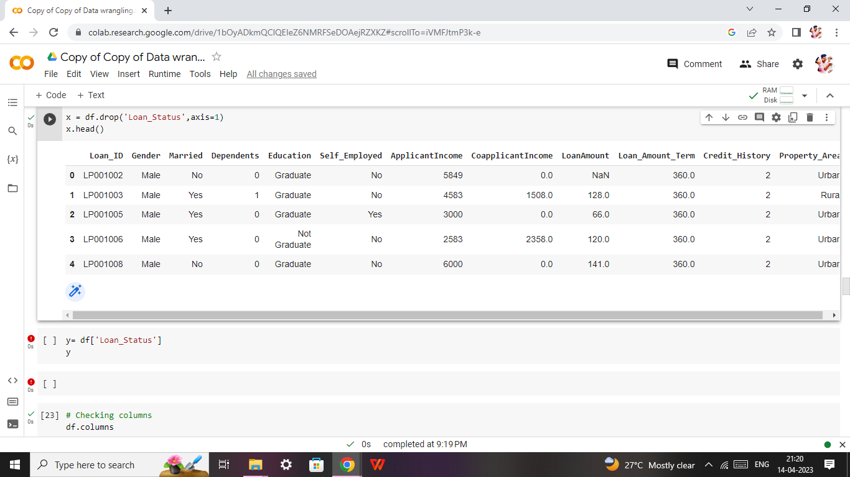

* **Model Building:**

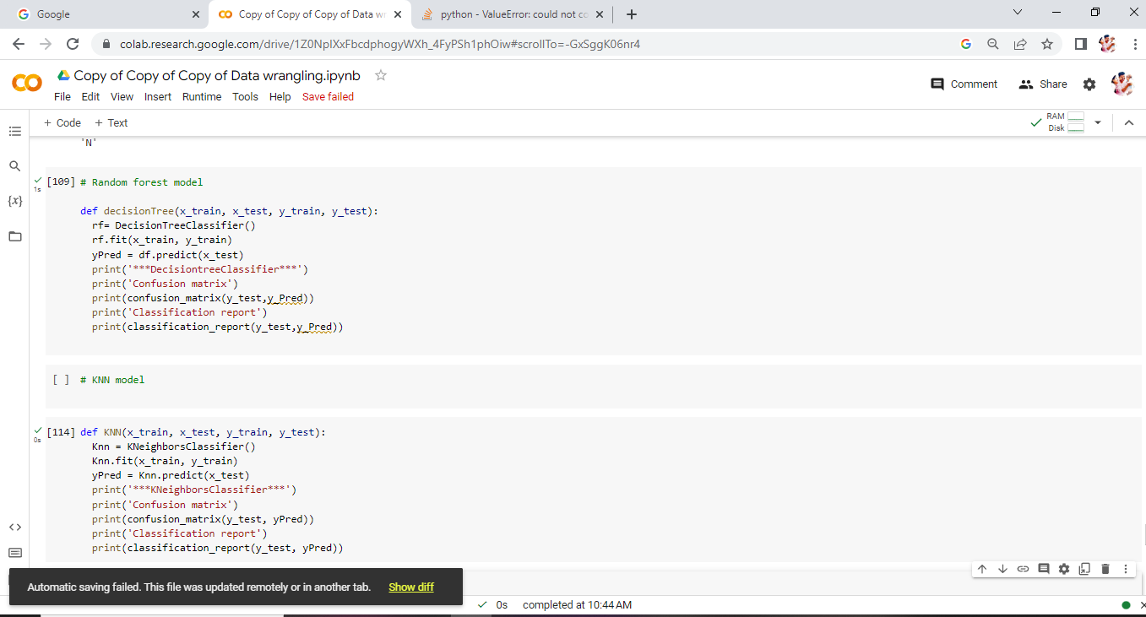

**4. ADVANTAGES AND DISADVANTAGES:**

**ADVANTAGES:**

* Spread the cost of a significant purchase safely
* Can help you manage your personal finances
* Ideal if you have struggled to save in the past
* Unsecured loans are not tied to assets

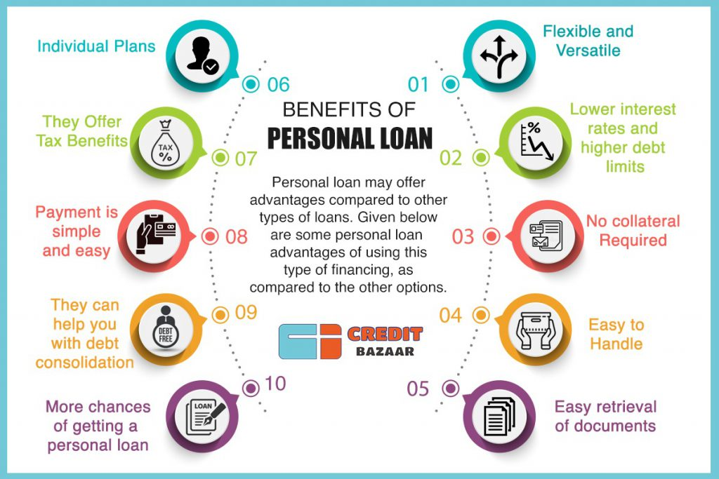

### Simple and Hassle-Free Application Process

Getting an personal loan involves a simple and hassle-free application process that makes it easy for you to address your financial emergencies on time. To get the loan, all you need to do is: visit the lender’s website or download the application. Then fill the application form online, upload documents and get the loan approved.

On successful loan approval, the loan amount is disbursed instantly or within 48 hours, depending on the lender you apply with. Few lenders in various countries like USA, Europe, India, Canada offer disbursal within 10 seconds. Whereas, few take a maximum of 48 hrs to disburse the amount. To avail this type of loan, you don’t have to visit the lender’s office or even wait for days to get the loan approved. Just by making the application from the comfort of your home, you can easily get the loan amount.

### Instant Disbursal on Personal Financing

As the name suggests, this type of loan is disbursed instantly, thereby making it easy for you to plan your finances or address emergencies quickly. With minimal documentation and easy application process, getting instant disbursal makes this loan product a popular one in the banking and loan industry.

### No Collateral Needed

Loan is a personal loan that does not require you to offer any collateral i.e. this type of loan amount is offer without having to keep any as security to the lender. This thus ensures that you are not at risk of losing your assets even in case of non-repayment of the loan amount.

However, in case of non-repayment of the loan, your credit score is affected and you would not be eligible to avail more loans in future or can avail the same at a high-interest rate. Therefore, timely repayment of the loan is important even with this loan being of the unsecured type.

### Minimal Documentation

Since the entire application for this type of loan can be done online, you can easily upload the documents online. This thus helps you in saving time and also does not require you to do any paperwork.  Similarly, when applying for a loan from the bank, you have to do paperwork or an executive will visit you to collect the documents.

### High Loan Amount

You can avail personal loan equal to your monthly salary or even 3 times of monthly salary easily from online lenders as well as various banks and NBFCs of any country. If you comply with the lender’s eligibility criteria and have a good credit score then getting a high loan amount at a low-interest rate is easy for you.

With a high loan amount offered instantly; you can easily take care of your financial needs without having to rely on your friends or family for help. You should also consider reading to manage your finances.

### Interest Rate on Personal Loan

Personal loan is offers low-interest rate that ensures you don’t have to pay back a high overall amount. The interest rate for this type of loan depends on your credit score and eligibility.

If you have a low credit score, then the loan amount offered is low and high-interest rate is applied. Whereas, with a high score, it is easy for you to get a high loan amount at a low-interest rate. Therefore, having a good credit score is essential to get a personal loan.

**DISADVANTAGES:**

**Long-term commitment**

* Good product requires a good credit score
* Certain loan types are riskier than others
* Will never get 0% interest - unlike a credit card or finance deal

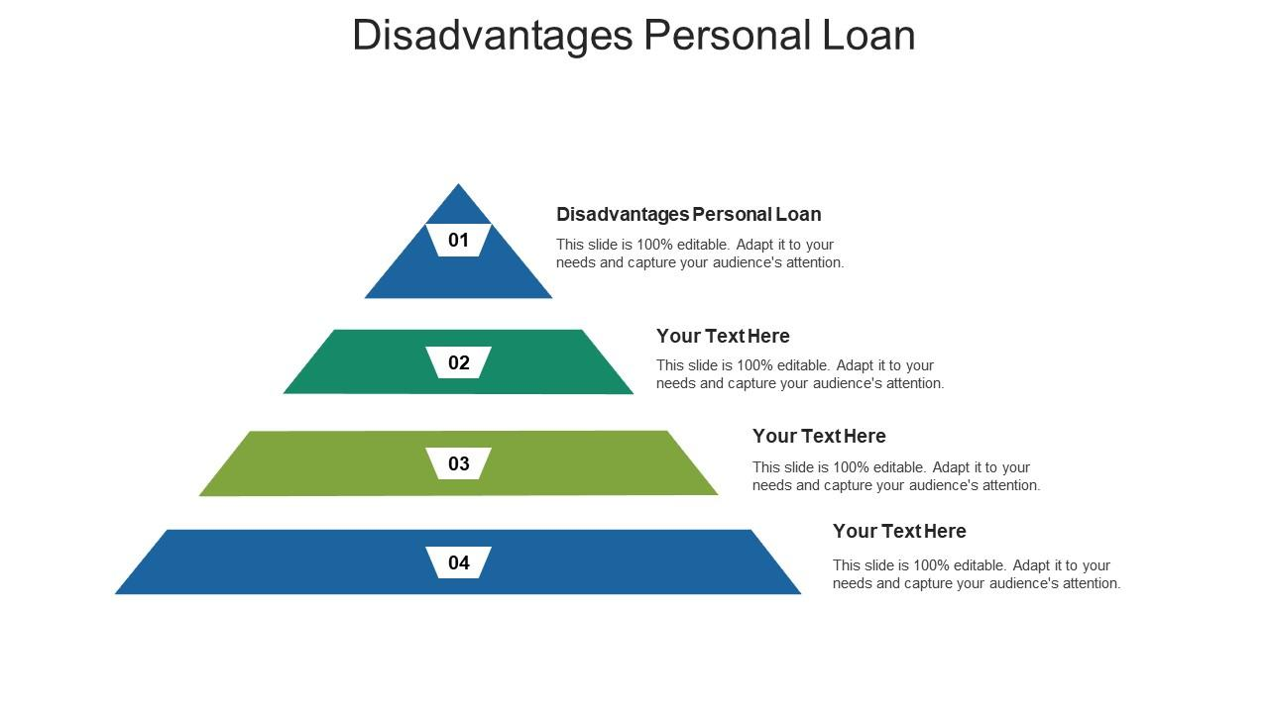

* **High-personal loan interest rates**:

As it does not require any security, they are regarded as high risk by the lenders. In order to offset their risks, these loans carry very high-interest charges.

* **Need for good credit rating:**

As these loans are quite risky, most lenders insist on their borrowers having a good credit rating. So if your credit rating is poor, due to failure to pay any loan, your application will be rejected. Hence this loan availability is subject to strict personal loan eligibility norms based on creditworthiness.

* **Variable loan and interest as per your credit rating**:

Even those lenders, who offer loans to the borrowers with a poor rating, end up offering lower principal amounts and higher interest as compared to those given to borrowers with good ratings. They also impose stricter repayment terms on these borrowers.

* **No part payments**:

Most lenders don’t allow part payment of loans. This means you end up paying the loan for the entire tenure of the loan. It can work out quite expensive since your initial instalments go towards interest payment

## Tough to Qualify

One of the greatest disadvantages to bank loans is that they are very difficult to obtain unless a small business has a substantial track record or valuable collateral such as real estate. Banks are careful to lend only to businesses that can clearly repay their loans, and they also make sure that they are able to cover losses in the event of default. Business borrowers can be required to provide personal guarantees, which means the borrower's personal assets can be seized in the event the business fails and is unable to repay all or part of a loan.

## High Interest Rates

Interest rates for small-business loans from banks can be quite high, and the amount of bank funding for which a business qualifies is often not sufficient to completely meet its needs. The high interest rate for the funding a business does receive often stunts its expansion, because the business needs to not only service the loan but also deal with additional funding to cover funds not provided by the bank.

**5. APPLICATIONS:**

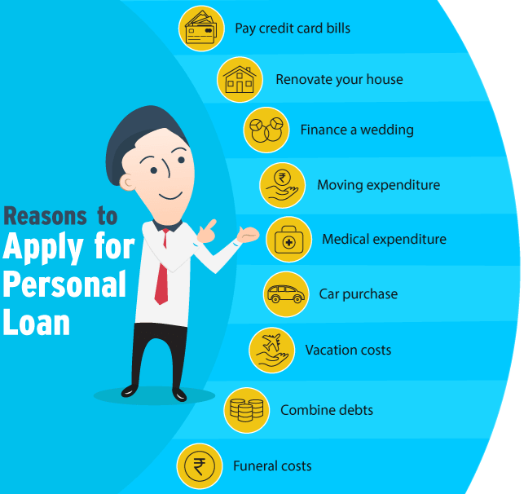

### Personal Loan Application Process Online

If the personal loan applicant has an existing relationship with the financial lender, he/she can apply for a personal loan via his/her net banking account and could possibly be eligible for a pre-approval. For other customers, they can apply for a personal loan online by following the steps mentioned below:

* Visit the website of the financial lender.
* Under the loan section, choose personal loans.
* Click on the ‘apply now’ option.
* Enter the details in the personal loan application form and submit it to the bank.
* The bank will assess the eligibility of the applicant and request for the submission of the required KYC documents and income documents.
* If the applicant is found eligible, the bank will disburse the loan amount to the bank account of the applicant, as mentioned in the application form.

### 2. Personal loan application offline

Listed below is the process of applying for a personal loan at the branch of the financial lender:

* Visit the branch of the financial lender.
* Procure the personal loan application form and enter all the required details.
* Submit relevant documents that prove one’s income, age, address and identity.
* The lender will then verify the documents and check the eligibility of the applicant.
* The loan amount will be transferred to the bank account of the applicant if he/she is found eligible.

### 3. Email and phone banking requests:

You can leave a request for personal loan with the bank through an email or at the customer service centre of the bank. The bank will review your eligibility and contact you to take the process further.

### 4. Request through ATM machine:

Nowadays you can [apply for personal loan](https://www.bankbazaar.com/personal-loan.html) via ATM kiosks as well. Once you raise a request the bank personnel will contact you.

**6. CONCLUSION:**

As you have researched, loans are expensive. Sometimes we need to consider the opportunity cost of decisions we make. Although we can afford the monthly payment for a vehicle loan, we need to look at how much interest on the loan will cost us. Having a better understanding of loans and interest rates will help you make large purchase decisions in the future.

**7. FUTURE SCOPE:**

**Changes in the average lifestyle:**

Then comes the fact that today’s lifestyle is more inclined towards making our lives easier and luxurious. Thus, this lifestyle often requires expensive appliances or services. This has led to a sharp rise in the expenses of an average man. Thus, the requirement for extra money which they can repay in installments later.

**Shattering of the high-interest rate taboo:**

Earlier, a personal loan used to be associated with higher interest rates as it is an unsecured loan. But with time, this fact has also changed. Personal loans today are available at rates as low as 10.75% which makes it more appealing to the future audience.

**Increasing market:**

Until a few years back, personal loans were availed by people who had a strong financial base. But today the ticket size has reduced to the extent of being afforded by smaller financial institutions. And their customer base is widespread.

**Tones of options:**

Innumerable institutions with neck-to-neck offers are available for every individual at every point in time. The customers have the liberty to decide which one they want to associate with. Instead of them asking for these banks to give them a loan.

**Increased financial awareness:**

The people today are less scared of taking a personal loan or exploring any financial scheme. Especially less than they were about 10 years ago. The hesitance has morphed into interest and has been well tapped by the industry pioneers in time.

They say that the future is uncertain and no one knows what might happen tomorrow. Having said that, we have spent years into analyzing trends and developing various sciences. Hence we can always predict things to a certain extent at any point in time.

### ****8. APPENDIX:****

### ****A. Source code****

**IMPORTING THE LIBRARIES:**

import pandas as pd

import numpy as np

import pickle

import matplotlib.pyplot as plt

%matplotlib inline

import seaborn as sns

**READ THE DATASET:**

Data = pd.read_csv(‘loan_prediction.csv’)

data

**DATA PREPARATION:**

data.info()

data .is null().sum()

**HANDLING MISSING VALUES:**

data.info()

data.isnull().sum()

**HANDLING CATEGORICAL VALUES:**

data[‘Gender’]= data[‘Gender’]. astype(‘int64’)

data[‘Married’]= data[‘Married’]. astype(‘int64’)

data[‘Dependents’]=data[‘Dependents’]. astype(‘int64’)

data[‘Self_Employed’]=data[‘Self_Employed’]. astype(‘int64’)

data[‘CoapplicantIncome’]=data[‘CoapplicantIncome’].as type(‘int64’)

data[‘LoanAmount’]=data[‘LoanAmount’].astype(‘int64’)

data[‘Loan_Amount_Term’]=data[‘Loan_Amount_Term’].

astype(‘int64’)

data[‘Credit_History’]=data[‘Credit_History’].astype(int64’)

**HANDLING IMBALANCE DATA:**

from imblearn.combine import SMOTETomek

y = data[‘Loan_Status’]

x = data.drop(columns=[‘Loan_Status’],axis=1)

x_bal,y_bal = smote.fit_resample(x,y)

print(y.value_counts())

print(y.bal.value_counts())

**EXPLORATORY DATA ANALYSIS:**

**DESCRIPTIVE STATISTICAL:**

data.describe()

**VISUAL ANALYSIS:**

**UNIVARIATE ANALYSIS:**

plt.figure(figsize=(12,5))

plt.subplot(121)

sns.distplot(data[‘ApplicantIncome’], color=’r’)

plt.subplot(122)

sns.distplot(data[‘Credit_History’])

plt.show()

**BIVARIATE ANALYSIS:**

plt.figure(figsize=(18,4))

plt.subplot(1,4,1)

sns.countplot(data[‘Gender’])

plt.subplot(1,4,2)

sns.countplot(data[‘Education’])

plt.show()

plt.figure(figsize=(20,5))

plt.subplot(131)

sns. count plot(data[‘Married’], hue=data[‘Gender’])

plt.subplot(132)

sns. count plot(data[‘Self_Employed’], hue=data[‘Education’])

plt.subplot(133)

sns. count plot (data[‘Property_Area’], hue=data[‘Loan_Amount_Term’])

**MULTIVARIATE ANALYSIS**:

sns.swarmplot(data[‘Gender’],data[‘ApplicantIncome’], hue = data[‘Loan_Status’])

**SCALING THE DATA:**

Sc = StandardScaler()

x_bal= sc.fit_transform(x_bal)

x_bal = pd.DataFrame(x_bal,columns=names)

**SPLITTING DATA INTO TRAIN AND TEST:**

X_train,X_test,y_train,y_test=train_test_split(x_bal,y_bal,test_size=0.33,random_state=42)

**MODEL BUILDING:**

**TRAINING THE MODEL IN MULTIPLE ALGORITHMS:**

**DECISION TREE MODEL:**

def decisionTree(x_train,x_test,y_train, y_test)

dt=DecisionTreeClassifier()

dt.fit(x_train,y_train)

yPred = dt.predict(x_test)

print(‘***Decision Tree Classifier***’)

print(‘Confusion matrix’)

print(confusion_matrix(y_test,yPred))

print(‘Classification report’)

print(classification_report(y_test,yPred))

**RANDOM FOREST MODEL:**

def randomForest(x_train,x_test,y_train,y_test):

rf = RandomForestClassifier()

rf.fit(x_train,y_train)

yPred=rf.predict(x_test)

print(‘***Random Forest Classifier***’)

print(‘Confusion matrix’)

print(confusion_matrix(y_test,yPred))

print(‘Classification report’)

print(classification_report(y_test,yPred))

**KNN MODEL:**

def KNN(x_train,x_test,y_train,y_test):

knn = KNeighborsClassifier()

knn.fit(x_train,y_train)

yPred = knn.predict(x_test)

print(‘***KNeighborsClassifier***’)

print(‘Confusion matrix’)

print(confusion_matrix(y_test,yPred))

print(“Classification report’)

print(classification_report(y_test,yPred))

**XGBOOST MODEL**:

xg.fit(x_train,y_train)

def xgboost(x_train,x_test,y_train,y_test):

xg = GradientBoostingClassifier()

yPred = xg.predict(x_test)

print(‘***GradientBoostingClassifier***’)

print(‘Confusion matrix’)

print(confusion_matrix(y_test,yPred))

print(‘Classification report’)

print(classification_report(y_test, yPred))

**ANN model:**

Import tensortflow

From tensortflow.keras.models import Sequential

From tensortflow.leras.layers import Dense

classifier=Sequential()

classifier.add(Dense(units=100,activation=’relu’,input_dim=11)

classifier.add(Dense(units=50,activation=’relu’))

classifier.add(Dense(units=1,activation=’sigmoid’))

classifier.compile(optimizer=’adam’,loss’binary_crossentropy’,metrics=[‘accuracy’])

Model_history=classifier.fit(x_train,y_train,batch_size=100,validation_split=0.2,epochs=100)

**TESTING THE MODEL:**

dtr.predict([[1,1,0,1,1,4276,1542,145,240,0,1]])

rfr.predict([[1,1,0,1,1,4276,1542,145,240,0,1]])

Knn.predict([[1,1,0,1,1,4276,1542,145,240,0,1]])

Xgb.predict([[1,1,0,1,1,4276,1542,145,240,0,1]])

Classifier.save(“loan.h5”)

Y_pred=classifier.predict(x_test)

y_pred

y_pred={y_pred>0.5)

y_pred

def predict_exit(sample_value):

sample_value= np.array(sample_value)

sample_value contains onlyn1 record

sample_value=sample_value.reshape(1,-1)

sample_value= sc.transform(sample_value)

return classifier.predict(sample_value)

sample_value=[[1,1,0,1,1,4276,1542,145,240,0,1]]

if predict_exit(sample_value)>0.5

print(‘Prediction: High chance of Loan Approval!’)

else:

print(‘Prediction: Low chance Loan Approval.’)

sample_value=[[1,1,0,1,1,45,14,45,240,1,1]]

if predict_exit(sample_value)>0.5:

print(‘Prediction: High chance of Loan Approval!’)

else:

print(‘Prediction: Low chance of Loan Approval.’)

**PERFORMANCE TESTING & HYPERPARAMETER TUNING**

**COMPARE THE MODEL:**

def compareModel(x_train,x_test,y_train,y_test):

decisionTree(x_train,x_test,y_train,y_test)

print(‘-’*100)

RandomForest(x-train,x_test,y_train,y_test)

print(‘-‘*100)

XGB(x-train,x_test,y_train,y_test)

print(‘-‘*100)

KNN(x_train,x_test,y_train,y_test)

print(‘-’*100)

compareModel(x_tarin,x_test,y_train,y_test)

yPred=classifier.predict(x_test)

print(accurancy_score(y_pred,y_test))

print(“ANN Model”)

print(“Confusion_Matrix”)

print(confusion_matrix(y_test,y_pred))

print(“classification Report”)

print(classification_report(y_test,y_pred))

**COMPARING MODEL ACCURACY BEFORE & AFTER APPLYING HYPERPARAMETER TUNING:**

from sklearn .model_selection import cross_val_scorerf = RandomForestClassifier()

rf.fit(x_train,y_train)

yPred = rf.predict(x_test)

f1_score(yPred,y_test,average=’weighted’)

0.9679166666666668

cv = cross_val_score(rf,x,y,cv=5)

np.mean(cv)

0.985

**MODEL DEPLOYEMENT:**

**SAVE THE BEST MODEL:**

pickle..dump(model,open(‘rdf.pk1’,’wb’))

**Creating templates**

* **Home.html**
* **Predict.html**

**Import the libraries:**

from flask import Flask, render_template, request

import numpy as np

import pickle

app=Flask(__name__)

model=pickle.load(open(r’rdf.pkl’,’rb’))

scale=pickle.load(open(r’scale1.pkl’,’rb’))

@app.route(‘/’)

Def home():

Return render_template(‘home.html’)

@app.route(‘/submit’,methods=[“POST”,”GET”])

Def submit():

Input_feature=[int(x) for x in request.form.values()]

Input_feature=[np.array(input_feature)]

Print(input_feature)

Name=[‘Gender’,Married,’Dependents’,’Education’,’Self_Employed’,’ApplicantIncome’,

Data= pandas.DataFrame(input_feature,columns=names)

Print(data)

Prediction=model.predict(data)

Print(prediction)

Prediction=int(prediction)

Print(type(prediction))

If (prediction==0)

Return render_template(“output.html,result=”Loan will Not Be Approved”)

Else:

Retrun render_template(“output.html”,result=”Loan will Be Approved”)

If__name__==”__main__”:

Port=int(os.environ.get(‘PORT’,5000))

App.run(debug=false)